Using Gulp for Deployment

**Gulp and Powershell :** If you don’t have licence for TDS and need to move items to target instance using gulp and powershell :)

Gulp can be used to build and deploying process really quick - You can configure a number tasks and make sure the build reaches the target site instance and runs seamlessly !

1. Create a gulp-config.js to store the config json.

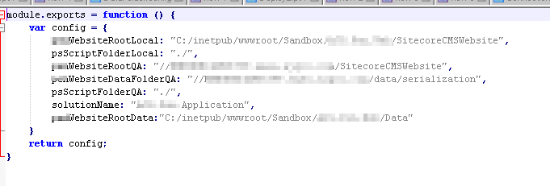

1. Make a text file with item path which needs to be moved to destination site instance - name the file name as SitecoreItemPath

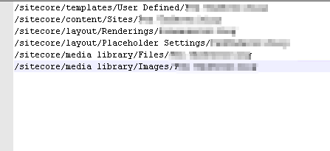

1. Configuring Gulp task

***Steps involved -> Serialize-Items >> Publish Serialized Items to Destination >> Deserialize Items >> Build and Publish Files***

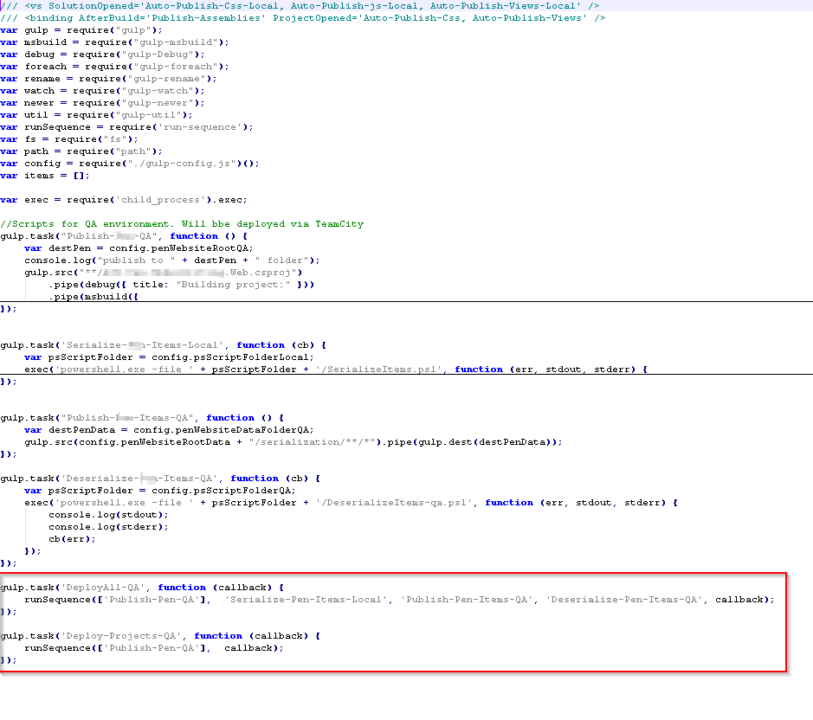

1. Few more powershell scripts To Serialize and Deserialize items

**Steps to Serialize items:**

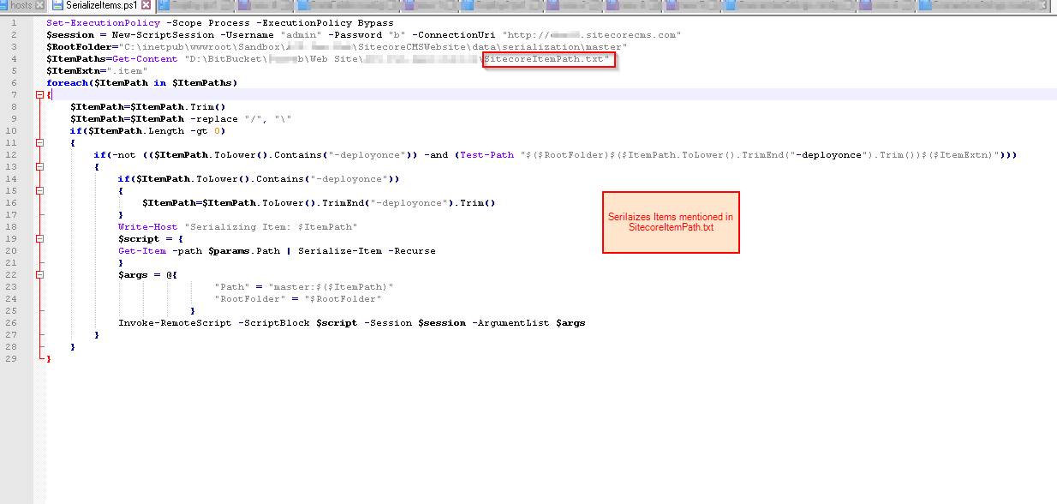

**Steps to De-Serialize items:**

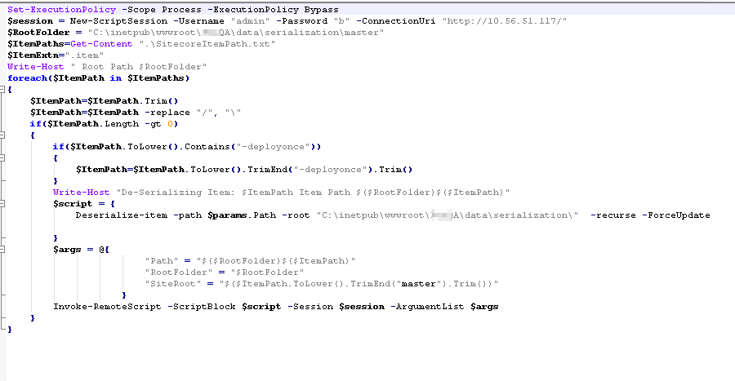

1. Now run the Tasks using Task Runner in Visual Studio -- Tada !! your contents are moved to target instance !!

